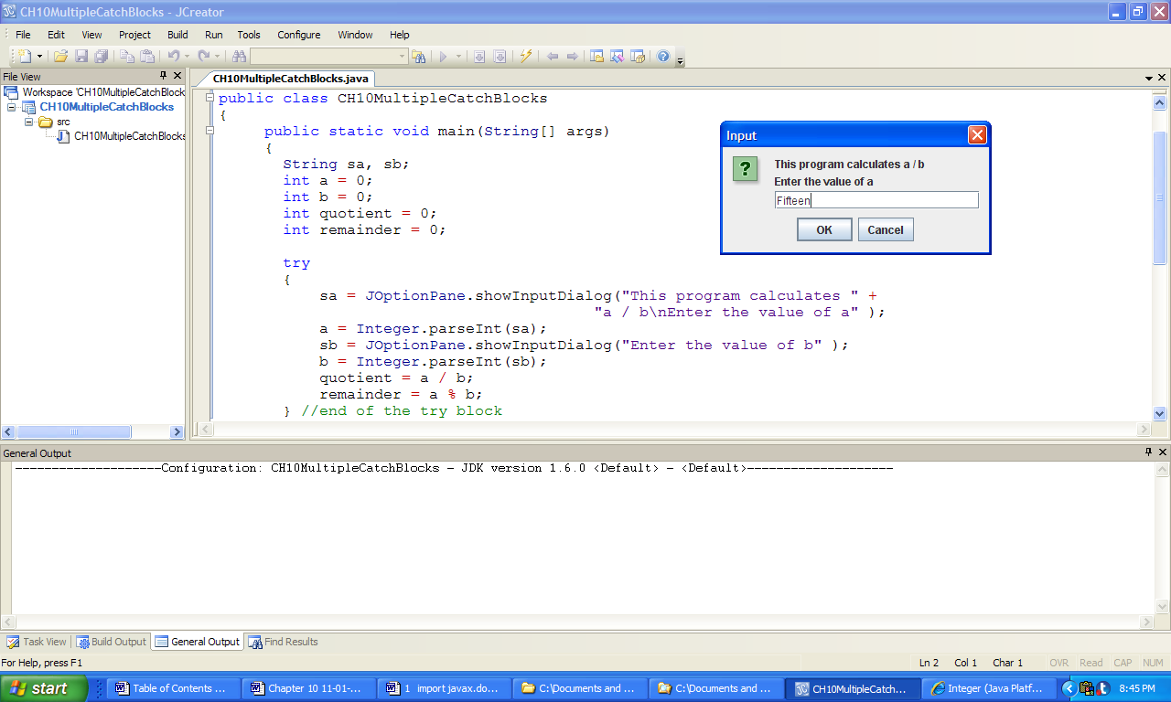 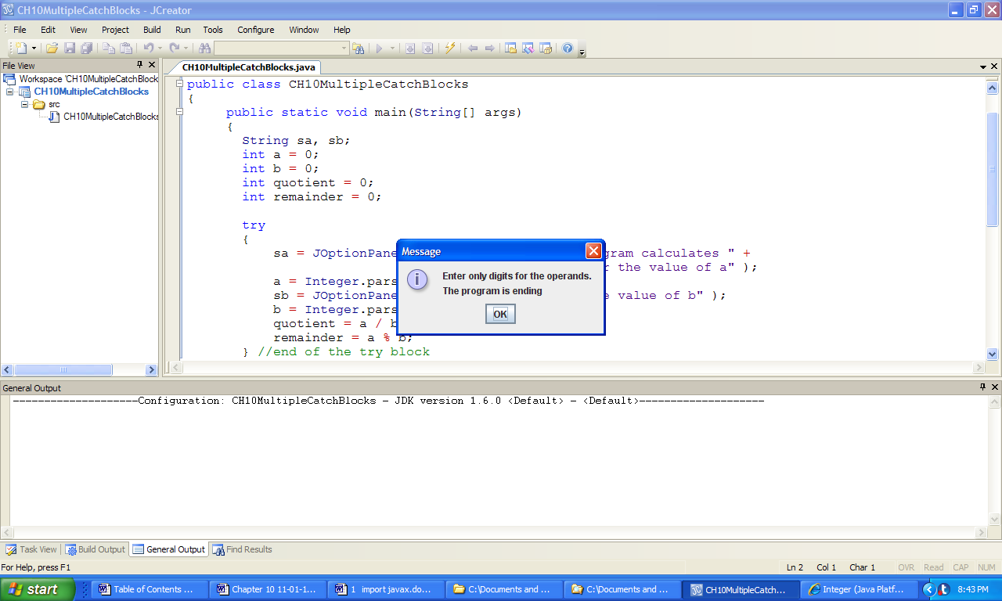

**Figure 10.7 Outputs produced by the application MultipleCatchBlocks.**